**PSAppDeployToolkit (PSADT)**

The PSADT is a PowerShell-based framework that simplifies application deployment for enterprises. It provides a structured approach to scripting and deploying applications, offering features like user interface elements, pre-defined functions and an ADT Session object to store deployment information.

1. **Platform Value**

* Simplifies Complex Scripting
* Consistent User Experience
* Improved Deployment Success
* Open-Source and Contributed

1. **Concepts**

* ADTSession Object
* Pre-defined Functions
* Exit Codes
* Deployment Structure
* Deployment Modes

1. **Usage**

* Deploying Applications
* Scripting Deployment Logic
* Using Functions
* Running Scripts
* Utilizing ADTSession

**Folder Structure of PSADT**

The PSAppDeployToolkit uses a specific folder structure to organize deployment packages and their associated files.

**Key Folders:**

* **Toolkit:** Contains the PSAppDeployToolkit framework itself including the necessary files and folders for creating deployment packages.
* **Files:** Where you store the installation files for the application you're deploying.
* **SupportFiles:** An optional folder to store files that support the deployment such as configuration files or scripts.
* **Deploy-Application.exe:** The executable file used to execute the deployment script.
* **Deploy-Application.ps1:** The PowerShell script that contains the logic for deploying the application.
* **Strings:** Contains the UI messages for the deployment process including English and other languages.
* **Images:** Holds images used in the deployment UI such as application logos or icons.

**Configuration:** Contains configuration files including the main configuration file (Deploy-Configuration.psd1).

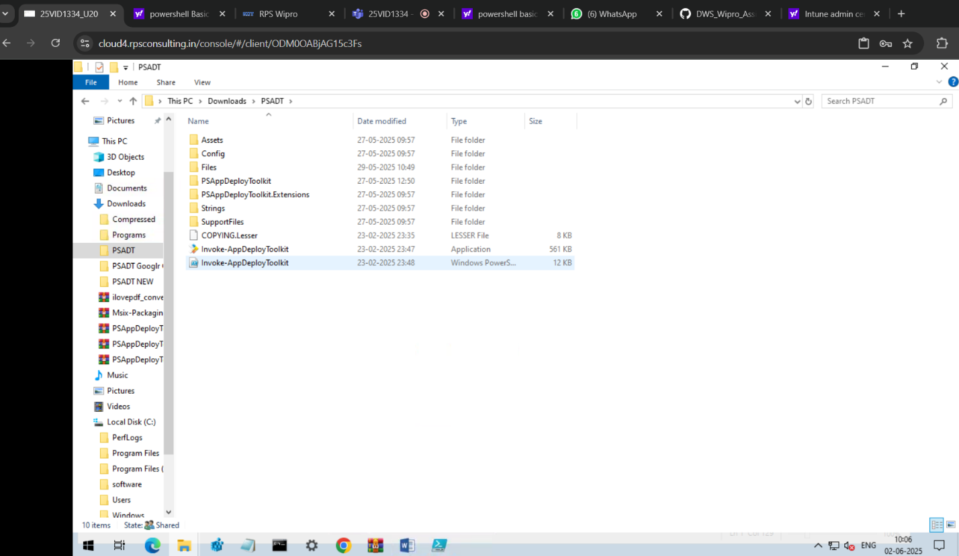

**Template Script in PSADT**

The PSAppDeployToolkit provides template scripts for application deployment. These scripts like Deploy-Application.ps1 are designed to streamline the deployment process and ensure consistency across deployments.

1. **Understanding PSAppDeployToolkit and Templates**

* PSAppDeployToolkit is a framework that simplifies complex scripting for enterprise application deployment.
* It provides a set of pre-defined functions for common deployment tasks.
* Template scripts like Deploy-Application.ps1 are designed to be customized to meet specific deployment requirements.

1. **Using the Template Script (Deploy-Application.ps1)**

* The Deploy-Application.ps1 script is a template that can be used for both installing and uninstalling applications.
* You can edit the script in the Windows PowerShell ISE application to customize it for your specific needs.
* The AppDeployToolkitMain.ps1 script contains the logic and functions for installing or uninstalling applications.

1. **Creating a New Deployment Using Templates**

* PSAppDeployToolkit provides internal templates that can be used to create new deployments.
* To create a deployment using the PSADT v3 compatible template, we can use the command **New-ADTTemplate -Destination C:\Temp\MyAppDeployment -Name "MyOldAppDeployment" -Version 3**
* To create a deployment using the PSADT v4 native template, we can use the command **New-ADTTemplate -Destination C:\Temp\MyAppDeployment -Name "MyAppDeployment"**

**Commands:**

**New-ADTTemplate -Destination C:\Temp\MyAppDeployment -Name "MyAppDeployment"**

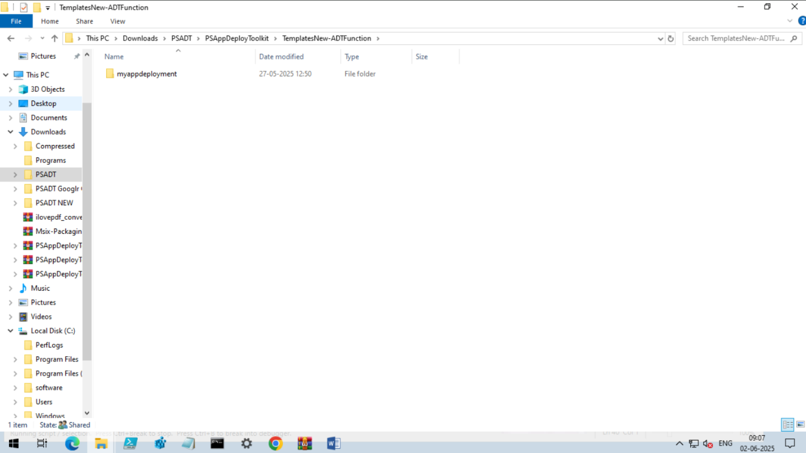

**Practical Commands:**



